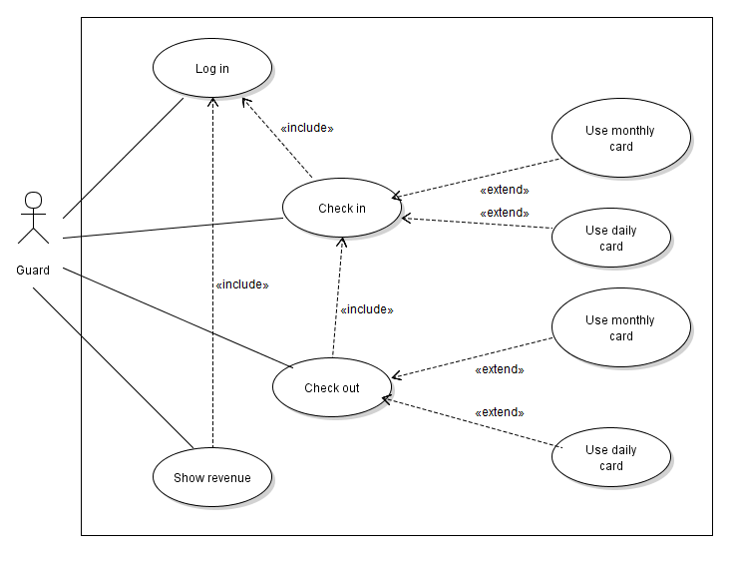

**Use Case 1: Login**

|  |  |
| --- | --- |
| Name | Login |
| ID | UC01 |
| Description | User login into the system |
| Actors | Guard |
| Organizational Benefits | Guard can login into the system and manage their private account |
| Triggers | Guard opens the application and selects login |
| Preconditions | App was started |
| Postconditions | User is logged in |
| Main Course | 1. Enter username 2. Enter password and hide password 3. Prevent SQL injection 4. The system validates the entered name and password then logs the user into the system 5. Display login successfully |
| Alternate Courses | AC1: Username or password is invalid   1. Display an error message that username or password may be incorrect 2. Return user to MC step 1 |
| Exceptions | EX1: App determines user is already logged on   1. App notifies user that account is already logged on 2. Return user to main interface |

**Use Case 2: Check in**

|  |  |
| --- | --- |
| Name | Check in |
| ID | UC02 |
| Description | While a car arrives at the parking lot, a manager can check remaining parking space and save license plate to system |
| Actors | Guard |
| Organizational Benefits | Reduce workload for guard and manager |
| Triggers | The user enters id card and selects an option to save data in system |
| Preconditions | User is logged in |
| Postconditions | System saved this ID, license plate and check-in time when user views a success message |
| Main Course | 1. Enter ID card 2. Check ID card 3. Enter license plate 4. Check in(AC1, AC2) 5. System saves check in and notifies that check in was successful (EX2) |
| Alternate Courses | AC1(step 4.1): Driver uses daily card   1. System saves license plate to this ID 2. Return user to Main Course step 5   AC2(step 4.2): Driver uses monthly card   1. Check license plate of this car and license plate in database(EX1) 2. Return user to Main Course step 5 |
| Exceptions | EX1: Monthly card is out of date   1. System notifies user that this card is out of date 2. Return user to Main Course step 1   EX2: System fails on check in   1. System notifies user that an error has occurred 2. Return user to Main Course step 1   EX3: This card was damaged   1. System notifies user that card was damaged 2. Return user to Main Course step 1   EX4: License plate of this car does not match the data of card in system   1. System notifies user that check in fail because license plate of this car does not match 2. Return user to Main Course step 1 |

**Use Case 3: Check out**

|  |  |
| --- | --- |
| Name | Check out |
| ID | UC03 |
| Description | While a car leaves the parking lot, the manager can issue an invoice to the driver |
| Actors | Guard |
| Organizational Benefits | Reduce workload for guard and manager |
| Triggers | Enter id card and select an option to do it |
| Preconditions | User is logged in |
| Postconditions | System displays license plate, this card is daily or monthly and issue an invoice if this card is a daily card |
| Main Course | 1. Enter ID card 2. Enter license plate 3. Check this license plate and license plate in data of card 4. Checks this card is daily card or monthly card (EX1) 5. Check out (AC1, AC2) 6. System notifies that check out was successful |
| Alternate Courses | AC1(Step 5.1): This card is daily card   1. Display license plate and delete data in this ID card 2. Issue an invoice 3. Return user to MC step 5   AC2(Step 5.2): This card is monthly card   1. Display license plate 2. Return user to MC step 5 |
| Exceptions | EX1: This ID was not checked in   1. System notifies user that this ID was not checked in 2. Return user to Main Course step 1   EX2: Monthly card is out of date   1. System notifies user that this card is out of date 2. Return user to Alternate Courses 1 step 2   EX3: System fails on check out   1. System notifies user that an error has occurred 2. Return user to Main Course step 1   EX4: License plate of this car does not match the data of card in system   1. System warning user that check out fail because license plate of this car does not match 2. Return user to Main Course step 1 |

**Use Case 4: Show revenue**

|  |  |
| --- | --- |
| Name | Show revenue |
| ID | UC04 |
| Description | Show revenue by shift |
| Actors | Guard |
| Organizational Benefits | Increase sales by data analysis |
| Triggers | The manager selects an option to show revenue |
| Preconditions | User is logged in |
| Postconditions | User views revenue data |
| Main Course | 1. Check login time 2. Calculates total amount in all bills of this shift 3. Display revenue in shift |
| Alternate Courses | None |
| Exceptions | None |